Downloading...
From: https://drive.google.com/uc?id=1VJaDVtDUtKQMmhRAqr3t-fgng899ZdRV
To: /content/Python Application Usage Log Data Set.xlsx
100%|██████████| 1.68M/1.68M [00:00<00:00, 133MB/s]
DEBUG:cmdstanpy:input tempfile: /tmp/tmpi7go4u91/8cpcnn9k.json
DEBUG:cmdstanpy:input tempfile: /tmp/tmpi7go4u91/adj7_ab_.json
DEBUG:cmdstanpy:idx 0
DEBUG:cmdstanpy:running CmdStan, num_threads: None
DEBUG:cmdstanpy:CmdStan args: ['/usr/local/lib/python3.12/dist-packages/prophet/stan_model/prophet_model.bin', 'random', 'seed=25490', 'data', 'file=/tmp/tmpi7go4u91/8cpcnn9k.json', 'init=/tmp/tmpi7go4u91/adj7_ab_.json', 'output', 'file=/tmp/tmpi7go4u91/prophet_modelcwjr9ze6/prophet_model-20251017042921.csv', 'method=optimize', 'algorithm=lbfgs', 'iter=10000']
04:29:21 - cmdstanpy - INFO - Chain [1] start processing
INFO:cmdstanpy:Chain [1] start processing
04:29:24 - cmdstanpy - INFO - Chain [1] done processing
INFO:cmdstanpy:Chain [1] done processing
DEBUG:cmdstanpy:input tempfile: /tmp/tmpi7go4u91/d1_gjlk8.json
DEBUG:cmdstanpy:input tempfile: /tmp/tmpi7go4u91/6tpvnalh.json
DEBUG:cmdstanpy:idx 0
DEBUG:cmdstanpy:running CmdStan, num_threads: None
DEBUG:cmdstanpy:CmdStan args: ['/usr/local/lib/python3.12/dist-packages/prophet/stan_model/prophet_model.bin', 'random', 'seed=58445', 'data', 'file=/tmp/tmpi7go4u91/d1_gjlk8.json', 'init=/tmp/tmpi7go4u91/6tpvnalh.json', 'output', 'file=/tmp/tmpi7go4u91/prophet_modelcv72ne_f/prophet_model-20251017043016.csv', 'method=optimize', 'algorithm=lbfgs', 'iter=10000']
04:30:16 - cmdstanpy - INFO - Chain [1] start processing
INFO:cmdstanpy:Chain [1] start processing
04:30:20 - cmdstanpy - INFO - Chain [1] done processing
INFO:cmdstanpy:Chain [1] done processing
DEBUG:cmdstanpy:input tempfile: /tmp/tmpi7go4u91/spomgs68.json
DEBUG:cmdstanpy:input tempfile: /tmp/tmpi7go4u91/7dgfiyu7.json
DEBUG:cmdstanpy:idx 0
DEBUG:cmdstanpy:running CmdStan, num_threads: None
DEBUG:cmdstanpy:CmdStan args: ['/usr/local/lib/python3.12/dist-packages/prophet/stan_model/prophet_model.bin', 'random', 'seed=97649', 'data', 'file=/tmp/tmpi7go4u91/spomgs68.json', 'init=/tmp/tmpi7go4u91/7dgfiyu7.json', 'output', 'file=/tmp/tmpi7go4u91/prophet_modelakzn5yym/prophet_model-20251017043114.csv', 'method=optimize', 'algorithm=lbfgs', 'iter=10000']
04:31:14 - cmdstanpy - INFO - Chain [1] start processing
INFO:cmdstanpy:Chain [1] start processing
04:31:17 - cmdstanpy - INFO - Chain [1] done processing
INFO:cmdstanpy:Chain [1] done processing
DEBUG:cmdstanpy:input tempfile: /tmp/tmpi7go4u91/rx5qfs_f.json
DEBUG:cmdstanpy:input tempfile: /tmp/tmpi7go4u91/cyhjd3df.json
DEBUG:cmdstanpy:idx 0
DEBUG:cmdstanpy:running CmdStan, num_threads: None
DEBUG:cmdstanpy:CmdStan args: ['/usr/local/lib/python3.12/dist-packages/prophet/stan_model/prophet_model.bin', 'random', 'seed=40407', 'data', 'file=/tmp/tmpi7go4u91/rx5qfs_f.json', 'init=/tmp/tmpi7go4u91/cyhjd3df.json', 'output', 'file=/tmp/tmpi7go4u91/prophet_modelu5xq4hc_/prophet_model-20251017043211.csv', 'method=optimize', 'algorithm=lbfgs', 'iter=10000']
04:32:11 - cmdstanpy - INFO - Chain [1] start processing
INFO:cmdstanpy:Chain [1] start processing
04:32:14 - cmdstanpy - INFO - Chain [1] done processing
INFO:cmdstanpy:Chain [1] done processing
DEBUG:cmdstanpy:input tempfile: /tmp/tmpi7go4u91/gm35m_8p.json
DEBUG:cmdstanpy:input tempfile: /tmp/tmpi7go4u91/4c_mmsib.json
DEBUG:cmdstanpy:idx 0
DEBUG:cmdstanpy:running CmdStan, num_threads: None
DEBUG:cmdstanpy:CmdStan args: ['/usr/local/lib/python3.12/dist-packages/prophet/stan_model/prophet_model.bin', 'random', 'seed=27001', 'data', 'file=/tmp/tmpi7go4u91/gm35m_8p.json', 'init=/tmp/tmpi7go4u91/4c_mmsib.json', 'output', 'file=/tmp/tmpi7go4u91/prophet_modelyosk6jkx/prophet_model-20251017043305.csv', 'method=optimize', 'algorithm=lbfgs', 'iter=10000']
04:33:05 - cmdstanpy - INFO - Chain [1] start processing
INFO:cmdstanpy:Chain [1] start processing
04:33:08 - cmdstanpy - INFO - Chain [1] done processing
INFO:cmdstanpy:Chain [1] done processing
DEBUG:cmdstanpy:input tempfile: /tmp/tmpi7go4u91/sn2pwe2x.json
DEBUG:cmdstanpy:input tempfile: /tmp/tmpi7go4u91/hual0nzz.json
DEBUG:cmdstanpy:idx 0
DEBUG:cmdstanpy:running CmdStan, num_threads: None
DEBUG:cmdstanpy:CmdStan args: ['/usr/local/lib/python3.12/dist-packages/prophet/stan_model/prophet_model.bin', 'random', 'seed=28415', 'data', 'file=/tmp/tmpi7go4u91/sn2pwe2x.json', 'init=/tmp/tmpi7go4u91/hual0nzz.json', 'output', 'file=/tmp/tmpi7go4u91/prophet_modelkz29zjt6/prophet_model-20251017043401.csv', 'method=optimize', 'algorithm=lbfgs', 'iter=10000']
04:34:01 - cmdstanpy - INFO - Chain [1] start processing
INFO:cmdstanpy:Chain [1] start processing
04:34:04 - cmdstanpy - INFO - Chain [1] done processing
INFO:cmdstanpy:Chain [1] done processing
DEBUG:cmdstanpy:input tempfile: /tmp/tmpi7go4u91/ycfsbypu.json
DEBUG:cmdstanpy:input tempfile: /tmp/tmpi7go4u91/lmn3yfuz.json
DEBUG:cmdstanpy:idx 0
DEBUG:cmdstanpy:running CmdStan, num_threads: None
DEBUG:cmdstanpy:CmdStan args: ['/usr/local/lib/python3.12/dist-packages/prophet/stan_model/prophet_model.bin', 'random', 'seed=28635', 'data', 'file=/tmp/tmpi7go4u91/ycfsbypu.json', 'init=/tmp/tmpi7go4u91/lmn3yfuz.json', 'output', 'file=/tmp/tmpi7go4u91/prophet_modeloi2awfrw/prophet_model-20251017043500.csv', 'method=optimize', 'algorithm=lbfgs', 'iter=10000']
04:35:00 - cmdstanpy - INFO - Chain [1] start processing
INFO:cmdstanpy:Chain [1] start processing
04:35:03 - cmdstanpy - INFO - Chain [1] done processing
INFO:cmdstanpy:Chain [1] done processing
DEBUG:cmdstanpy:input tempfile: /tmp/tmpi7go4u91/t5bjc_ct.json
DEBUG:cmdstanpy:input tempfile: /tmp/tmpi7go4u91/1yy4yyvu.json
DEBUG:cmdstanpy:idx 0
DEBUG:cmdstanpy:running CmdStan, num_threads: None
DEBUG:cmdstanpy:CmdStan args: ['/usr/local/lib/python3.12/dist-packages/prophet/stan_model/prophet_model.bin', 'random', 'seed=86407', 'data', 'file=/tmp/tmpi7go4u91/t5bjc_ct.json', 'init=/tmp/tmpi7go4u91/1yy4yyvu.json', 'output', 'file=/tmp/tmpi7go4u91/prophet_modelc54lnfxt/prophet_model-20251017043604.csv', 'method=optimize', 'algorithm=lbfgs', 'iter=10000']
04:36:04 - cmdstanpy - INFO - Chain [1] start processing
INFO:cmdstanpy:Chain [1] start processing
04:36:08 - cmdstanpy - INFO - Chain [1] done processing
INFO:cmdstanpy:Chain [1] done processing
DEBUG:cmdstanpy:input tempfile: /tmp/tmpi7go4u91/6eh8p039.json
DEBUG:cmdstanpy:input tempfile: /tmp/tmpi7go4u91/knu8esww.json
DEBUG:cmdstanpy:idx 0
DEBUG:cmdstanpy:running CmdStan, num_threads: None
DEBUG:cmdstanpy:CmdStan args: ['/usr/local/lib/python3.12/dist-packages/prophet/stan_model/prophet_model.bin', 'random', 'seed=65079', 'data', 'file=/tmp/tmpi7go4u91/6eh8p039.json', 'init=/tmp/tmpi7go4u91/knu8esww.json', 'output', 'file=/tmp/tmpi7go4u91/prophet_modelaxyg5udh/prophet_model-20251017043704.csv', 'method=optimize', 'algorithm=lbfgs', 'iter=10000']
04:37:04 - cmdstanpy - INFO - Chain [1] start processing
INFO:cmdstanpy:Chain [1] start processing
04:37:08 - cmdstanpy - INFO - Chain [1] done processing
INFO:cmdstanpy:Chain [1] done processing
DEBUG:cmdstanpy:input tempfile: /tmp/tmpi7go4u91/axw6n0on.json
Best Prophet (CV): {'changepoint_prior_scale': 0.5, 'seasonality_mode': 'multiplicative'} CV MAPE: 11.58%
DEBUG:cmdstanpy:input tempfile: /tmp/tmpi7go4u91/i3l_th_e.json
DEBUG:cmdstanpy:idx 0
DEBUG:cmdstanpy:running CmdStan, num_threads: None
DEBUG:cmdstanpy:CmdStan args: ['/usr/local/lib/python3.12/dist-packages/prophet/stan_model/prophet_model.bin', 'random', 'seed=67325', 'data', 'file=/tmp/tmpi7go4u91/axw6n0on.json', 'init=/tmp/tmpi7go4u91/i3l_th_e.json', 'output', 'file=/tmp/tmpi7go4u91/prophet_model3cnx6kfb/prophet_model-20251017043824.csv', 'method=optimize', 'algorithm=lbfgs', 'iter=10000']
04:38:24 - cmdstanpy - INFO - Chain [1] start processing
INFO:cmdstanpy:Chain [1] start processing
04:38:29 - cmdstanpy - INFO - Chain [1] done processing
INFO:cmdstanpy:Chain [1] done processing
Best LSTM: {'units': 64, 'dropout': 0.2, 'window': 14} val_loss: 0.395395

HOLDOUT (28d) — MAE: 479.46 | RMSE: 637.20 | MAPE: 11.64% | Accuracy: 88.36%
Prophet-only HOLDOUT MAPE: 10.05% → ΔMAPE vs Hybrid: -1.59 pts
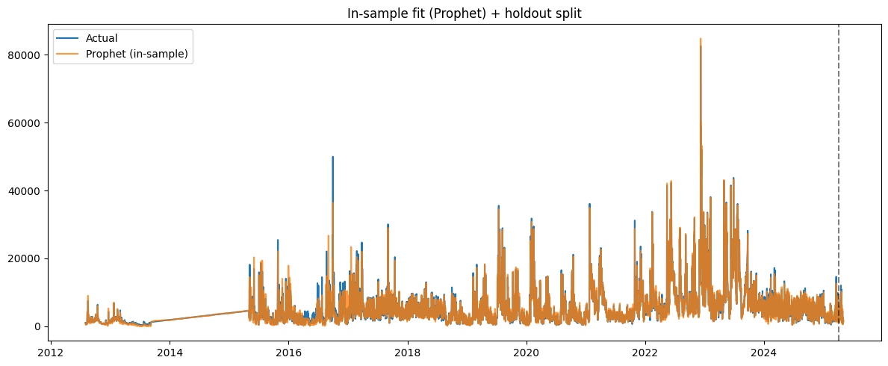
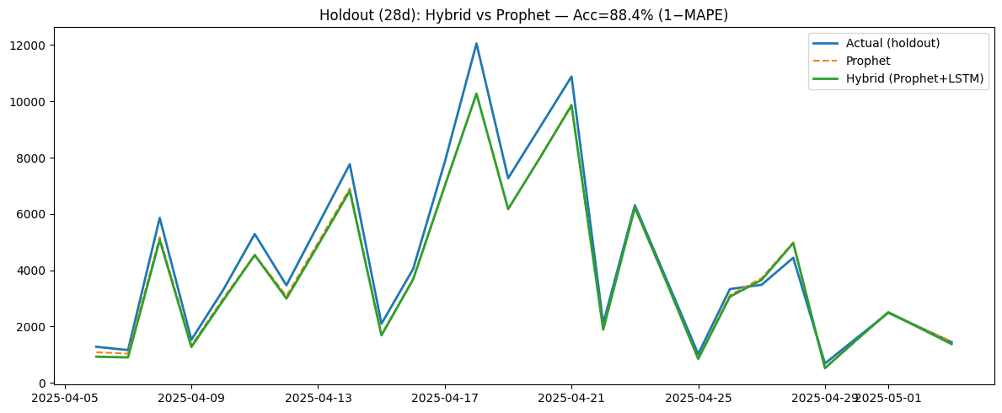
WARNING:absl:You are saving your model as an HDF5 file via `model.save()` or `keras.saving.save_model(model)`. This file format is considered legacy. We recommend using instead the native Keras format, e.g. `model.save('my_model.keras')` or `keras.saving.save_model(model, 'my_model.keras')`.

Artifacts saved to: /content/hybrid_90acc_artifacts
- 2year_forecast.csv
- lstm_residual.h5
- metrics.json
- prophet_global.json
- x_scaler.npy
- y_scaler.npy

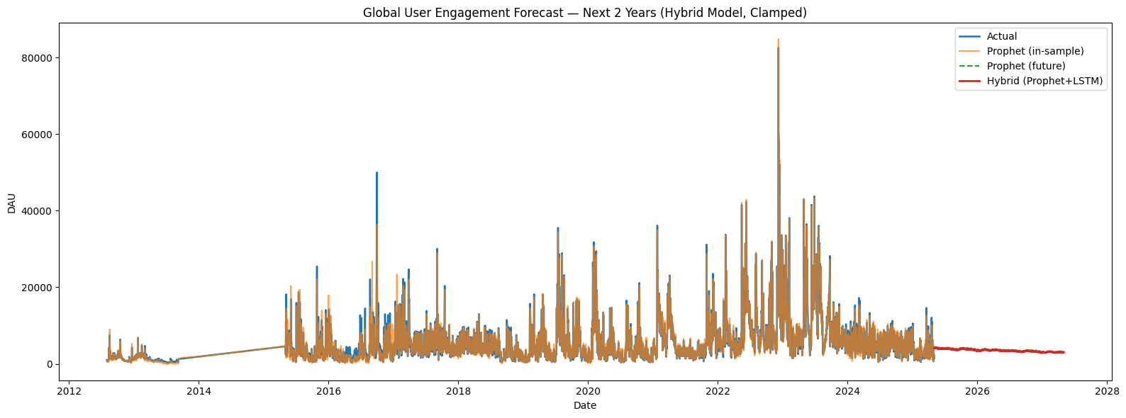
2-year forecast saved to: hybrid_90acc_artifacts/2year_forecast.csv

Last 28d Holdout Metrics:
MAE: 429.11
RMSE: 565.13
MAPE: 11.24%
Accuracy (1-MAPE): 88.76%
Best Prophet config: {'changepoint_prior_scale': 0.5, 'seasonality_mode': 'multiplicative'}
Best LSTM config: {'units': 96, 'dropout': 0.2, 'window': 21}
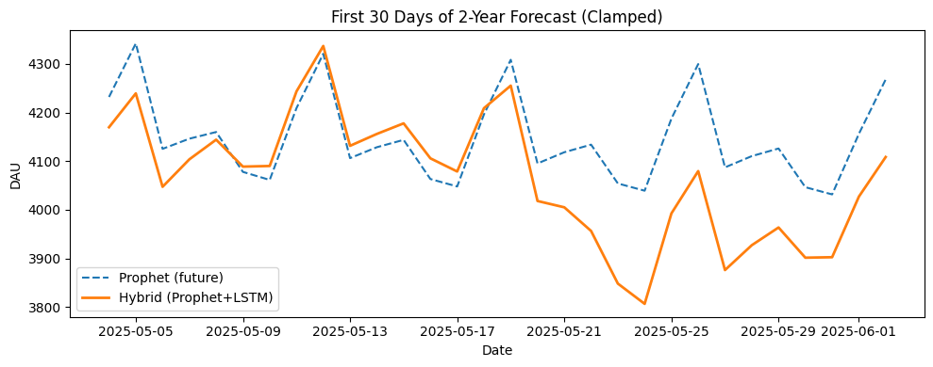

Exported files for deployment:
- 2year_forecast.csv
- lstm_residual.h5
- lstm_residual.keras
- metrics.json
- prophet_global.json
- x_scaler.npy
- y_scaler.npy

